Planning Awards 2024

Planning Law Firm of the Year

Supporting images
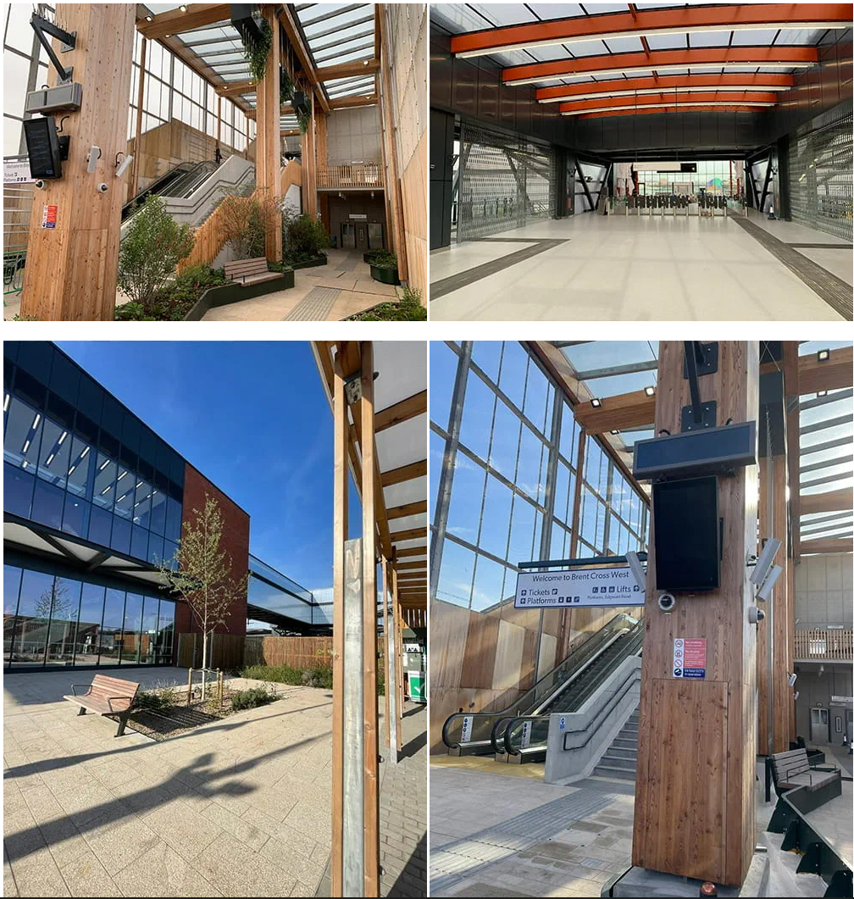
Brent Cross West Station
Image source: https://www.thameslinkrailway.com/travel-information/plan-your-journey/brent-cross-west-station
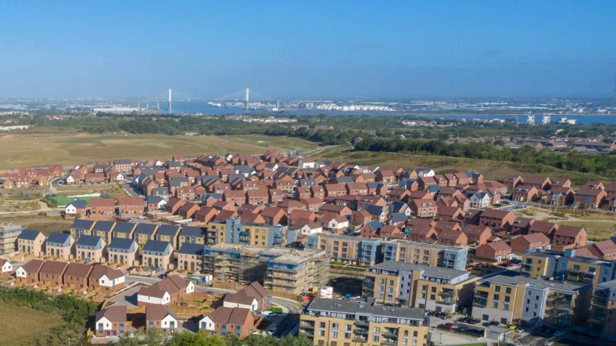
Ebbsfleet Garden City
Image source: https://ebbsfleetgardencity.org.uk/
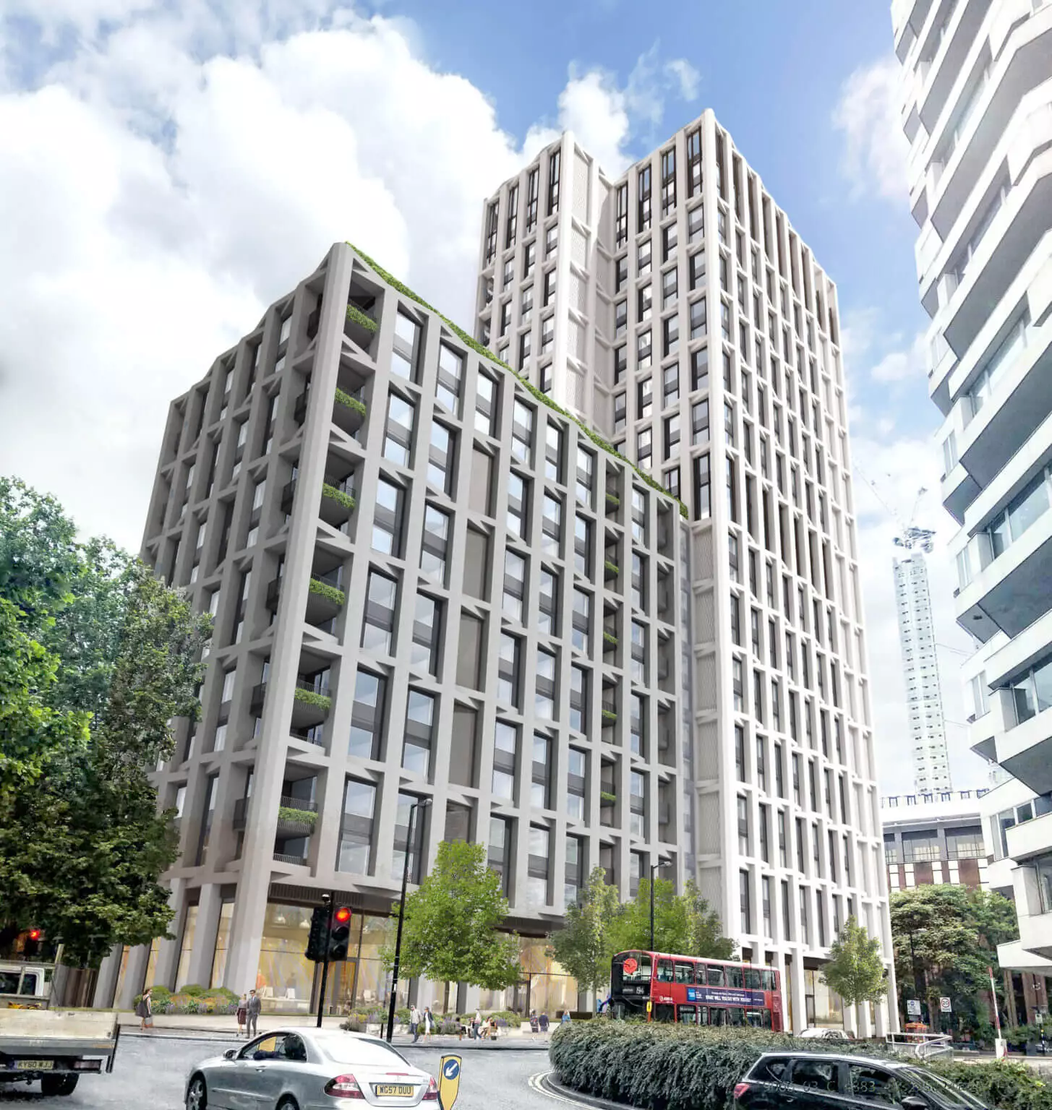
Fifth State and Wittington Investments were granted planning permission for a community-focused, mixed-use co-living development in the London Borough of Croydon
Image source: https://developcroydon.com/fifth-state-and-wittington-investments-received-planning-consent-for-co-living-development-on-addiscombe-road/

